**Diet, activity and health**

* There are health issues related to dietary excess or deficiency.
* It is important to include a variety of different activity in everyday living, supporting physical, social and mental wellbeing.

**Over nutrition**

The most common over nutrition problem is obesity caused by too much energy being consumed, or high levels of inactivity.

**Body Mass Index**

BMI measures your height and weight to work out if your weight is healthy.

**Activity recommendations**

**Pre-schoolers (3 to 4 years):** 180 minutes (3 hours) spread throughout the day, including at least 60 minutes of moderate-to-vigorous intensity physical activity

**Children and young people (5-18 years)**: at least 60 minutes of physical activity every day and engage in a variety of types and intensities of physical activity across the week.

**Adults (19-64 years):** at least 150 minutes each week (moderate intensity), or have 75 minutes of vigorous activity a week and do muscle strengthening activities on two days or more each week.

**A balanced diet**

A balanced diet is based on the Eatwell Guide. An unbalanced diet can lead to dietary related diseases.

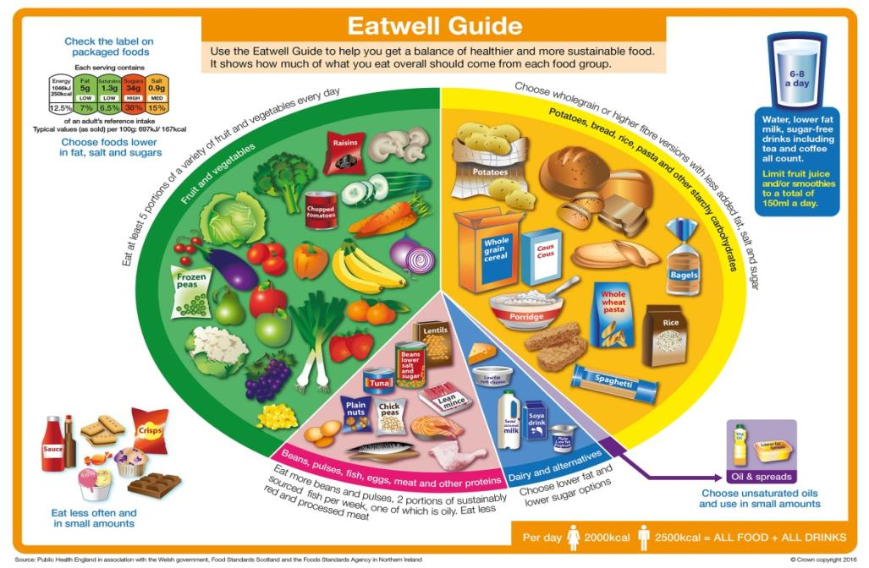

**Key terms**

**Deficiency diseases:** Adverse bodily conditions caused by a lack of a nutrient.

**Iron deficiency anaemia:** A condition caused by insufficient iron in the body. Common symptoms include tiredness and lethargy.

**Kwashiorkor**: A severe type of protein-energy malnutrition.

**Malnutrition**: When the diet does not contain the right amount of nutrients.

**Marasmus:** A severe type of energy malnutrition in all forms, including protein.

**Moderate activity**: Will raise your heart rate, and make you breathe faster and feel warmer.

**Obesity:** Extreme overweight. Obese adults have a BMI of 30 or above.

**Sedentary behaviour:** Requires little energy expenditure and includes sitting or lying down to watch television, use the computer, read, work or study, and sitting when travelling to school or work.

**Vigorous activity**: Makes you breathe hard and fast.

**Recommended BMI range (adults)**

Less than 18.5 Underweight  
**18.5 to 25 Desirable**  
25-30 Overweight  
30-35 Obese (Class I)  
35-40 Obese (Class II)  
Over 40 Morbidly obese

**Under nutrition**

Worldwide, Kwashiorkor and marasmus are two common diseases caused by a lack of protein and energy. Fat soluble vitamins (A, D, E and K) are stored in the body so it takes time for deficiency diseases to develop.

For more information, go to: <https://bit.ly/32BF4FJ>

**Anaemia**

Iron is vital for making red blood cells. Iron from the diet forms haemoglobin, which carries oxygen in the blood. Anaemia develops if the body’s stores of iron are too low.

**Bone health**

Calcium is important for strong bones. Vitamin D is needed for calcium to be absorbed from food.

**Diet and CHD**

It is believed that 80% of CHD and strokes could be prevented by changes to lifestyle factors, such as diet, physical activity and smoking.

Changes to the diet to reduce the risk of CHD include:

* increasing oily fish intake;
* reducing salt intake;
* increasing fruit and vegetables;
* decreasing alcohol consumption.

**Diet and cancer**

The World Cancer Research Fund

has released nine cancer prevention

recommendations.

* Be a healthy weight.
* Move more.
* Avoid high-calorie foods and drinks.
* Enjoy more grains, veg, fruit and barley.
* Limit intake of red meat and avoid processed meat.
* Don’t drink alcohol.
* Eat less salt.
* Don’t rely on supplements.
* Breastfeed your baby.

**Diet and health**

There is a link between a poor diet, and the risk of developing some diseases.

This includes the risk of:

* cancer;
* coronary heart disease (CHD);
* bone health;
* anaemia.

**Moderate activity**

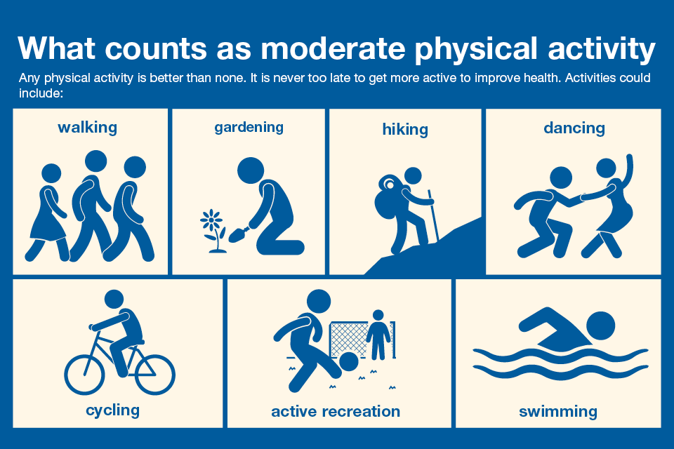

**Vigorous activity**



**Muscle strengthening activities**

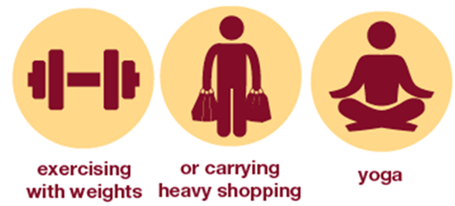

**Task**

Create a poster that contains information on what constitutes a healthy diet and some top tips on how to get active. Include information on how getting active and having a healthy diet can reduce the risk of some health issues and some other tips on how to reduce the risk of these.

**Inactivity**

It is also important that the amount of time being sedentary is reduced.

Over time, sedentary behaviour can lead to weight gain and obesity, which can increase the risk of developing chronic diseases in adulthood.

1 in 4 women and 1 in 5 men are classified as inactive (<30 mins per week).

**BMI = weight (kg)**

**(height in m)2**

**Energy in: food and drinks**

**Energy in > Energy out = Weight gain**

**Energy out: activity**

**Obesity**

People who are obese are more likely to suffer from CHD, type 2 diabetes, gall stones, arthritis, high blood pressure and some types of cancers, i.e. colon, breast, kidney and stomach.

**Malnutrition**

Having intakes of energy and/or nutrients below or in excess of needs for long periods of time can affect health.

The risk of **malnutrition** is increased by:

* increased requirements for some nutrients;
* restricted range of foods;
* reduction in available income;
* very low income;
* medical conditions;
* psychological conditions.